### **Academic English for Computer Science 5: General V Subject Specific Vocabulary**

|  |  |
| --- | --- |
|  | **This session aims to provide guidance on the following aspects of general and subject specific vocabulary:**   * **Analysing the vocabulary of lecture slides** * **Identifying subject terms in different kinds of texts** * **Words with general and subject specific meanings** |

**Where you see  please complete the task on Canvas if possible.** **Please remember to use headphones if you are listening (e.g. to pronunciation) on your own device.**

**_________________________________________________________________________**

**Activity 1: Vocabulary in lectures**

 **This activity should take around 10 minutes**

In the previous session we learnt that vocabulary can be organised into lists based on frequency of use. The General Service list (1K and 2K) contains the first two thousand most commonly used words in written English which make up about 80% of all texts. The Academic Word List (AWL) is a list of 570 word families of academic words that are commonly used across different disciplines. The AWL is divided into 10 sub-lists which group words in order of frequency.

** Task: Read a short text taken from some Computer Science lecture slides and answer questions 1-3 below.**

An array allows us to easily store multiple items of the same type. For now we are considering only the ‘built-in arrays’ (the arrays built in to the Java language). They offer more support than offered by arrays in other programming languages but they are still fairly basic. The items in an array are often called its elements. One of the key limitations of built-in arrays is that they are static. This means that the number of elements arrays can contain is fixed when they are created and cannot be altered afterwards.

1) What percentage of words in this text do you think comes from the General Service 1K list? _______________ %

2) Four words in this text are common academic words found on the AWL. Which words are they?

3) In addition to the word ‘Java’, the text contains two words that are used with a subject or semi-specialist meaning (i.e. the subject meaning is broadly similar to the general meaning of the word). What are they?



** Extension Activity:**

**Use the free online Vocabulary Analysis Tool LexTutor to check what kind of vocabulary a text contains.**

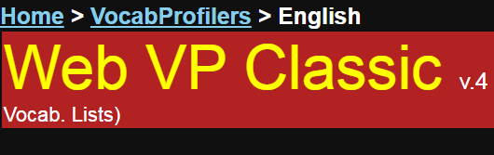

<https://www.lextutor.ca/vp/eng/>

Lextutor Vocab Profiler provides the following analysis of the text used in Activity 1:

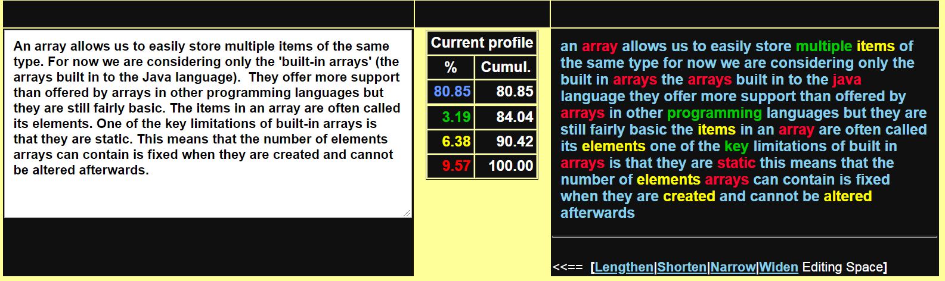

* K1 Words (1-1000) (blue): 80.85%
* K2 Words (1001-2000) (green): 3.19%
* AWL Words (yellow): 6.38%
* Off-List Words (red): 9.57%

**Make sure you know all the words in blue, green and yellow before trying to understand the text.**

**Try analysing some of the academic texts used on your courses or even analyse your own writing.**

**_________________________________________________________________________**

**Activity 2: Analysing texts [1]**

 **This activity should take around 10 minutes**

** Task: Read and compare three short texts and answer questions 1-3 below.**

1) One text is from lecture slides, one is from an online Java tutorial and the other is from an academic paper. Which text is easiest for you to understand? Why is it easier?

2) Which text appears to have the highest proportion of subject specific vocabulary? Can you find any examples?

3) Is it only subject specific vocabulary that makes a text harder to understand? What else can affect your understanding?

**Example 1 (slides)**

A nested loop can be used to sort an array into a specific order. For example, an array of integers can be sorted into an ascending or descending order. Consider the program on the next slide which implements a basic (inefficient) sort called bubblesort which sorts an array into ascending order. This algorithm is called bubbles or because in order to sort the array it ‘bubbles’ values ‘up’ the array, i.e. moves them along until they are in the correct position.

Source: Ian Kenny, University of Birmingham

**Example 2 (Online Java tutorial)**

A constructor initializes an object when it is created. It has the same name as its class and is syntactically similar to a method. However, constructors have no explicit return type. Typically, you will use a constructor to give initial values to the instance variables defined by the class, or to perform any other start-up procedures required to create a fully formed object. All classes have constructors, whether you define one or not, because Java automatically provides a default constructor that initializes all member variables to zero. However, once you define your own constructor, the default constructor is no longer used.

Source: https://www.tutorialspoint.com/java/java_constructors.htm

**Example 3 (Academic paper)**

Java modules assemble packages, classes, native code, and further resources, like simple JAR files. Yet, the new modules contain a static module descriptor which specifies the module’s unique name, its dependency on other modules, its exported packages, and a definition of re-exported dependencies. The module descriptor is processed by the Java compiler as well as the Java Virtual Machine (JVM), causing them to check and prevent access to the internal types of a module both at compile- and run-time. The dependencies between modules, as specified in the module descriptors, form an acyclic module graph. This module graph is used to resolve references between classes, replacing the previous class-loading based on the linear classpath.

Source: A. Dann, B. Hermann and E. Bodden, (2019). ModGuard: Identifying Integrity & Confidentiality Violations in Java Modules, IEEE Transactions on Software Engineering, 42, in press.

**Activity 3: Analysing texts [2]**

 **This activity should take around 10 minutes**

** Task: Refer to the table and answer the three questions below about word grammar.**

1) Look at the base words used to make some of the words in the texts above. What form of each base word is given in the text?

2) What class of words (grammar form) are the words as they appear in the text?

3) How has each word as it is used in the text been formed?

The first one has been done for you as an example.

|  |  |  |  |  |  |
| --- | --- | --- | --- | --- | --- |
|  | **Base Word** | **Word Class** | **Word in Text** | **Word Class** | **Formed by adding** |
|  | construct | VERB | constructor | NOUN | -or |
| 1 | vary | VERB |  |  |  |
| 2 | proceed | VERB |  |  |  |
| 3 | describe | VERB |  |  |  |
| 4 | compile | VERB |  |  |  |
| 5 | depend | VERB |  |  |  |
| 6 | pack | VERB |  |  |  |
| 7 | define | VERB |  |  |  |
| 8 | line | NOUN |  |  |  |
| 9 | syntax | NOUN |  |  |  |
| 10 | export | VERB |  |  |  |

 **Extension Activity:**

**Knowing the grammar of words is essential to help us work out the meaning as they are used in a sentence. Learn more about affixation (prefixes and suffixes) here:**



<http://www.uefap.com/vocab/build/building.htm>

**_________________________________________________________________________**

**Activity 4: General and specific meanings [1]**

 **This activity should take around 15 minutes**

Listening (and reading) is often challenging because words have different general and subject specific meanings. You may know the general meaning but not the subject specific meaning or vice versa. The following activities will look at some easy and more challenging words as examples.



** Task 1: Watch and listen to a short videoclip which is an extract from a lecture on Java. What does the lecturer mean when he uses words a-e? Choose the correct option, 1 2 or 3.**

|  |  |  |  |  |
| --- | --- | --- | --- | --- |
|  |  | **1** | **2** | **3** |
| **a** | **text** | A short message sent by mobile phone | A book or other form of printed matter | Unformatted writing |
| **b** | **program** | A set of instructions that performs a specific task when executed by a computer | A TV show (US spelling) |  |
| **c** | **class** | A social level | A lesson or group of students | A template used to create objects, and to define  object data types and methods |
| **d** | **method** | A procedure or way of doing something | A set of code that has a special name that must always be used |  |
| **e** | **main** | Most important or biggest | A principal pipe carrying water or gas to a building | A static driver method, which acts as an entry point to start the program |



** Task 2: In lectures you will hear many words that have different general and subject specific meanings.**

**Look at the following common words and some of their general meanings and answer the questions.**

1) Do you know what these words probably mean when used in Computer Science?

2) If you don’t know, how could you find out the Computer Science meaning?

|  |  |
| --- | --- |
|  | **General Meanings** |
| **Compile** | bring together, assemble or group |
| **Architecture** | style of buildings |
| **Execute** | put into practice; carry out a sentence of death |
| **Platform** | the place where people stand to wait for a train in a station; the basic principles of a political group; a high-heeled shoe |
| **Strut** | a stiff rod or bar; walk in an arrogant conceited way |
| **Array** | display or range of a particular type of thing |
| **Heap** | an untidy pile; a large amount |
| **Stack** | a tidy pile; a large chimney |
| **Queue** | a line of people waiting |
| **Tree** | a large green plant with leaves; a structure with branches |

|  |  |
| --- | --- |
| Top tip | There may be many more general meanings for a word, but often one of these is related to the subject specific meaning you are looking for. E.g. General meanings of ‘token’ (noun) include: (1) a symbolic gesture or physical representation e.g. ‘a token of our gratitude; (2) a piece of paper that can be exchanged for goods e.g. a ‘book token’ (3) a symbol or individual word. In Java, a ‘token’ is the smallest lexical unit in a program, relating to meaning (3). |

**_________________________________________________________________________**

**Activity 5: General and specific meanings [2]**

 **This activity should take around 5 minutes**

There may be *several* subject specific meanings for one word. For example, terms may have a specific Computer Science meaning when related to Java.

** Task: Look at the following definitions for the word ‘portable’ taken from Wikipedia.**

In **computing**:

* Portable object (computing), a distributed computing term for an object which can be accessed through a normal method call while possibly residing in memory on another computer
* Software portability, software that can easily be ported to multiple platforms
* Portable applications, applications that do not require any kind of installation onto a computer, and can store data in the program's directory

**Which meaning is intended on the slide below?**

PPT Slide: Introduction to Java
Java enables the creation of portable programs. 

** Extension Activity:**

**Find the subject specific meanings of the following terms with reference to Java.**

* constructor
* driver
* inheritance
* member
* member
* new

|  |  |
| --- | --- |
| Top tip | Many bilingual tools will not give the subject specific meaning that you need. You will build up your knowledge of subject specific meanings by attending lectures and reading recommended texts in your subject as lecturers and textbooks often explain core terms. |

**________________________________________________________________________**

**Summary:**

* Be aware that words have many different meanings in general English
* Words may also have more than one subject specific meaning
* You will build subject specific vocabulary by reading, regularly attending lectures and independent study



**Independent learning:**

Search for help with Java terminology on YouTube e.g. <https://www.youtube.com/watch?v=NUy_wOxOM8E>

**Reflection:**

What did you find most interesting or useful in today’s session? Add your ideas to the Canvas discussion.

Sources: All images are open-source and free of © restrictions.